**Uml Diagrams:**

**1]Use case diagram:**

**1.1Main Application start:**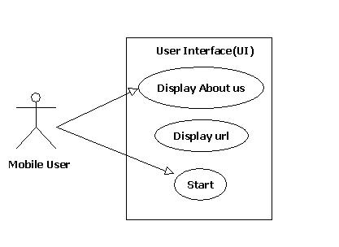

**1.2When User click on start:**

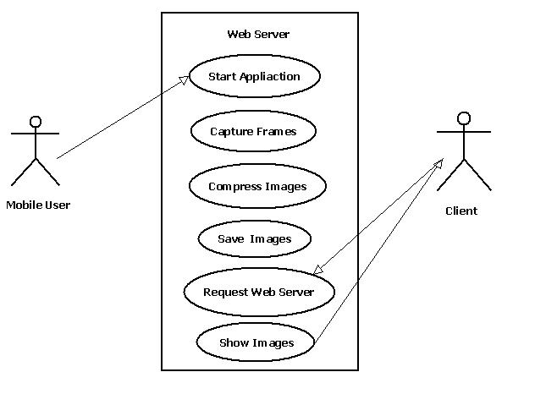

**1.3When user click on About us:**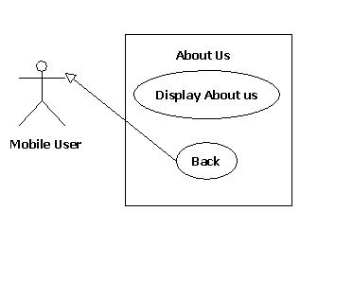

**2]State diagram:**

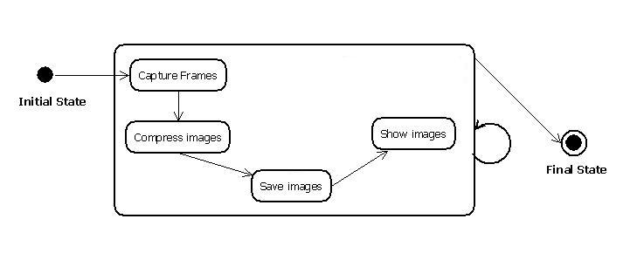

**3]Activity Diagram:**

